# Docker Compose Project Report – Uptime Kuma

Course: CYB-3353 System Administration

Student: Karim Haidari

Project: Docker Compose Lab (Project 2)

## 1. Introduction

This project demonstrates how to deploy a real-world application using Docker Compose on macOS. For this assignment, I deployed Uptime Kuma, a self‑hosted monitoring tool that tracks website uptime. The report includes installation steps, Docker verification, container deployment, Uptime Kuma setup, monitor creation, and application verification.

## 2. Installing Docker Desktop on macOS

I downloaded Docker Desktop for Mac (Apple Silicon) and completed installation with recommended settings. After launching Docker, I verified installation using the following commands:  
docker --version  
docker compose version  
Successful version output confirmed that Docker Engine and Docker Compose are functioning correctly.

## 3. Creating the Project Directory

I created a working directory for the project using the following commands:  
mkdir uptime-kuma  
cd uptime-kuma  
Inside this folder, I created my docker-compose.yml file using nano and later opened it in VS Code.

## 4. docker-compose.yml File

The docker-compose.yml file defines the Uptime Kuma service, mapped ports, a persistent data volume, and restart policy. This is the content used:  
  
version: "3.9"  
  
services:  
 uptime-kuma:  
 image: louislam/uptime-kuma:latest  
 container_name: uptime-kuma  
 ports:  
 - "3001:3001"  
 volumes:  
 - uptime-kuma-data:/app/data  
 restart: always  
  
volumes:  
 uptime-kuma-data:

## 5. Deploying Uptime Kuma

To deploy the container, I executed:  
docker compose up -d  
  
Docker pulled the image, created the container, started the service, and mapped port 3001 successfully. The container then appeared in Docker Desktop with a running status.

## 6. Accessing the Web Interface

Once the container was running, I visited http://localhost:3001 in my browser. The Uptime Kuma setup screen appeared, confirming successful deployment. After creating my admin account, I accessed the dashboard.

## 7. Creating a Website Monitor

To validate application functionality, I added a monitor:  
- Type: HTTP(s)  
- Name: Google  
- URL: https://www.google.com  
  
After saving, Uptime Kuma immediately checked the website and reported it as UP, displaying response time and uptime status.

## 8. Verification in Docker Desktop

Docker Desktop displayed the uptime-kuma container running successfully. I also reviewed container logs and confirmed the mapped ports and created volumes.

## 9. Conclusion

This project demonstrated successful installation of Docker Desktop, use of Docker Compose, container deployment, and application configuration. Uptime Kuma is fully operational and monitoring a real website. This assignment improved my understanding of containerization, service deployment, and system administration workflows.

## 10. Screenshots

The following screenshots document each step of the project:

### Screenshot 2025-11-13 at 10.14.05 PM.png

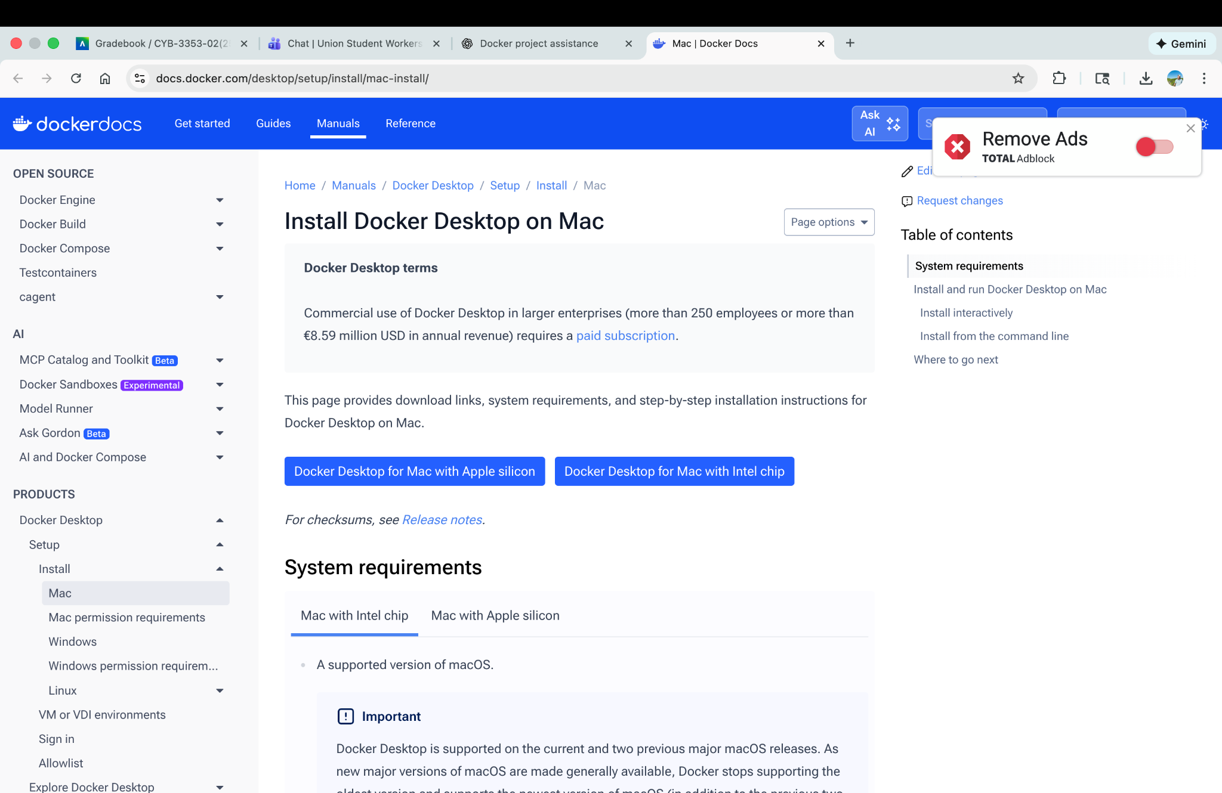

### Screenshot 2025-11-13 at 10.21.34 PM.png

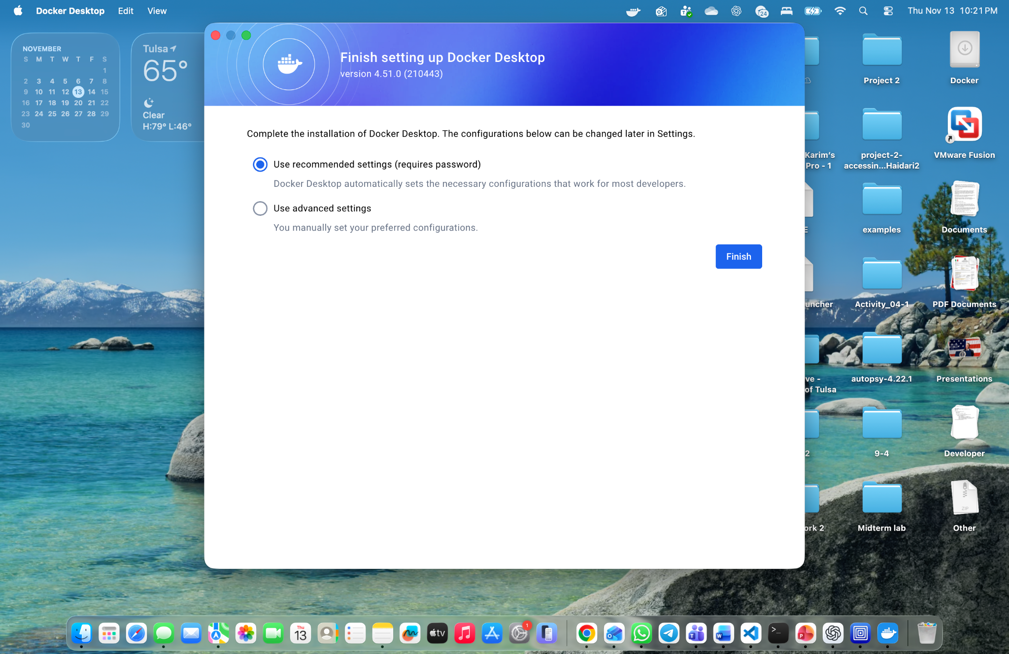

### Screenshot 2025-11-13 at 10.22.10 PM.png

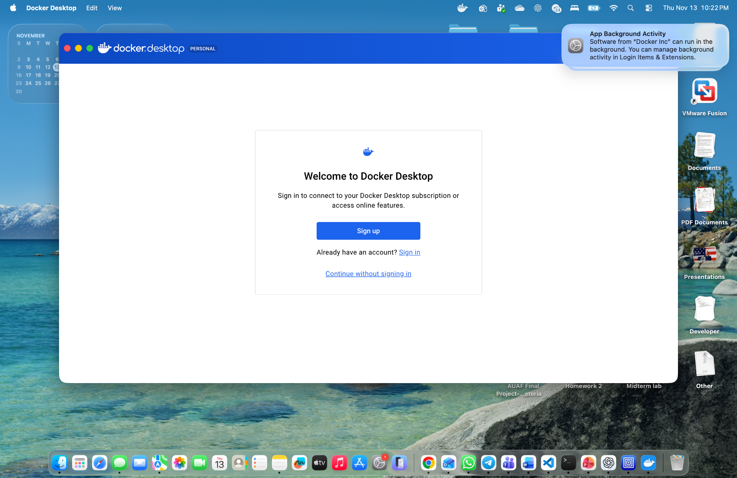

### Screenshot 2025-11-13 at 10.23.29 PM.png

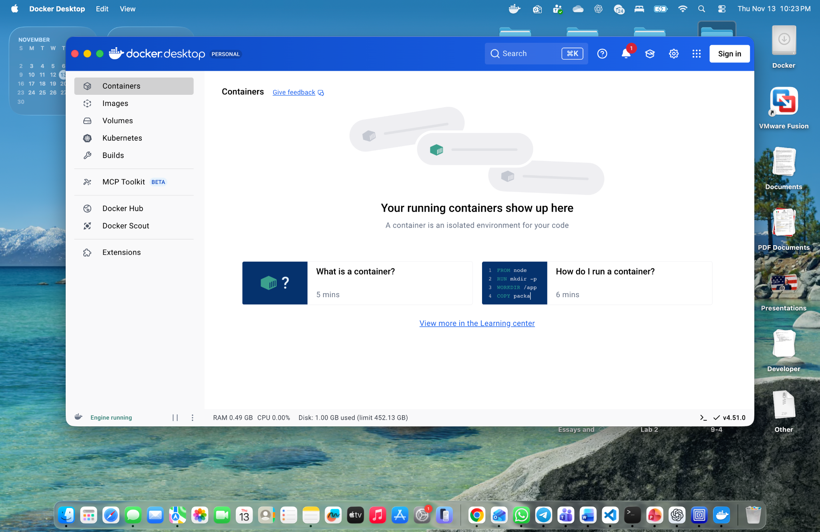

### Screenshot 2025-11-13 at 10.24.09 PM.png

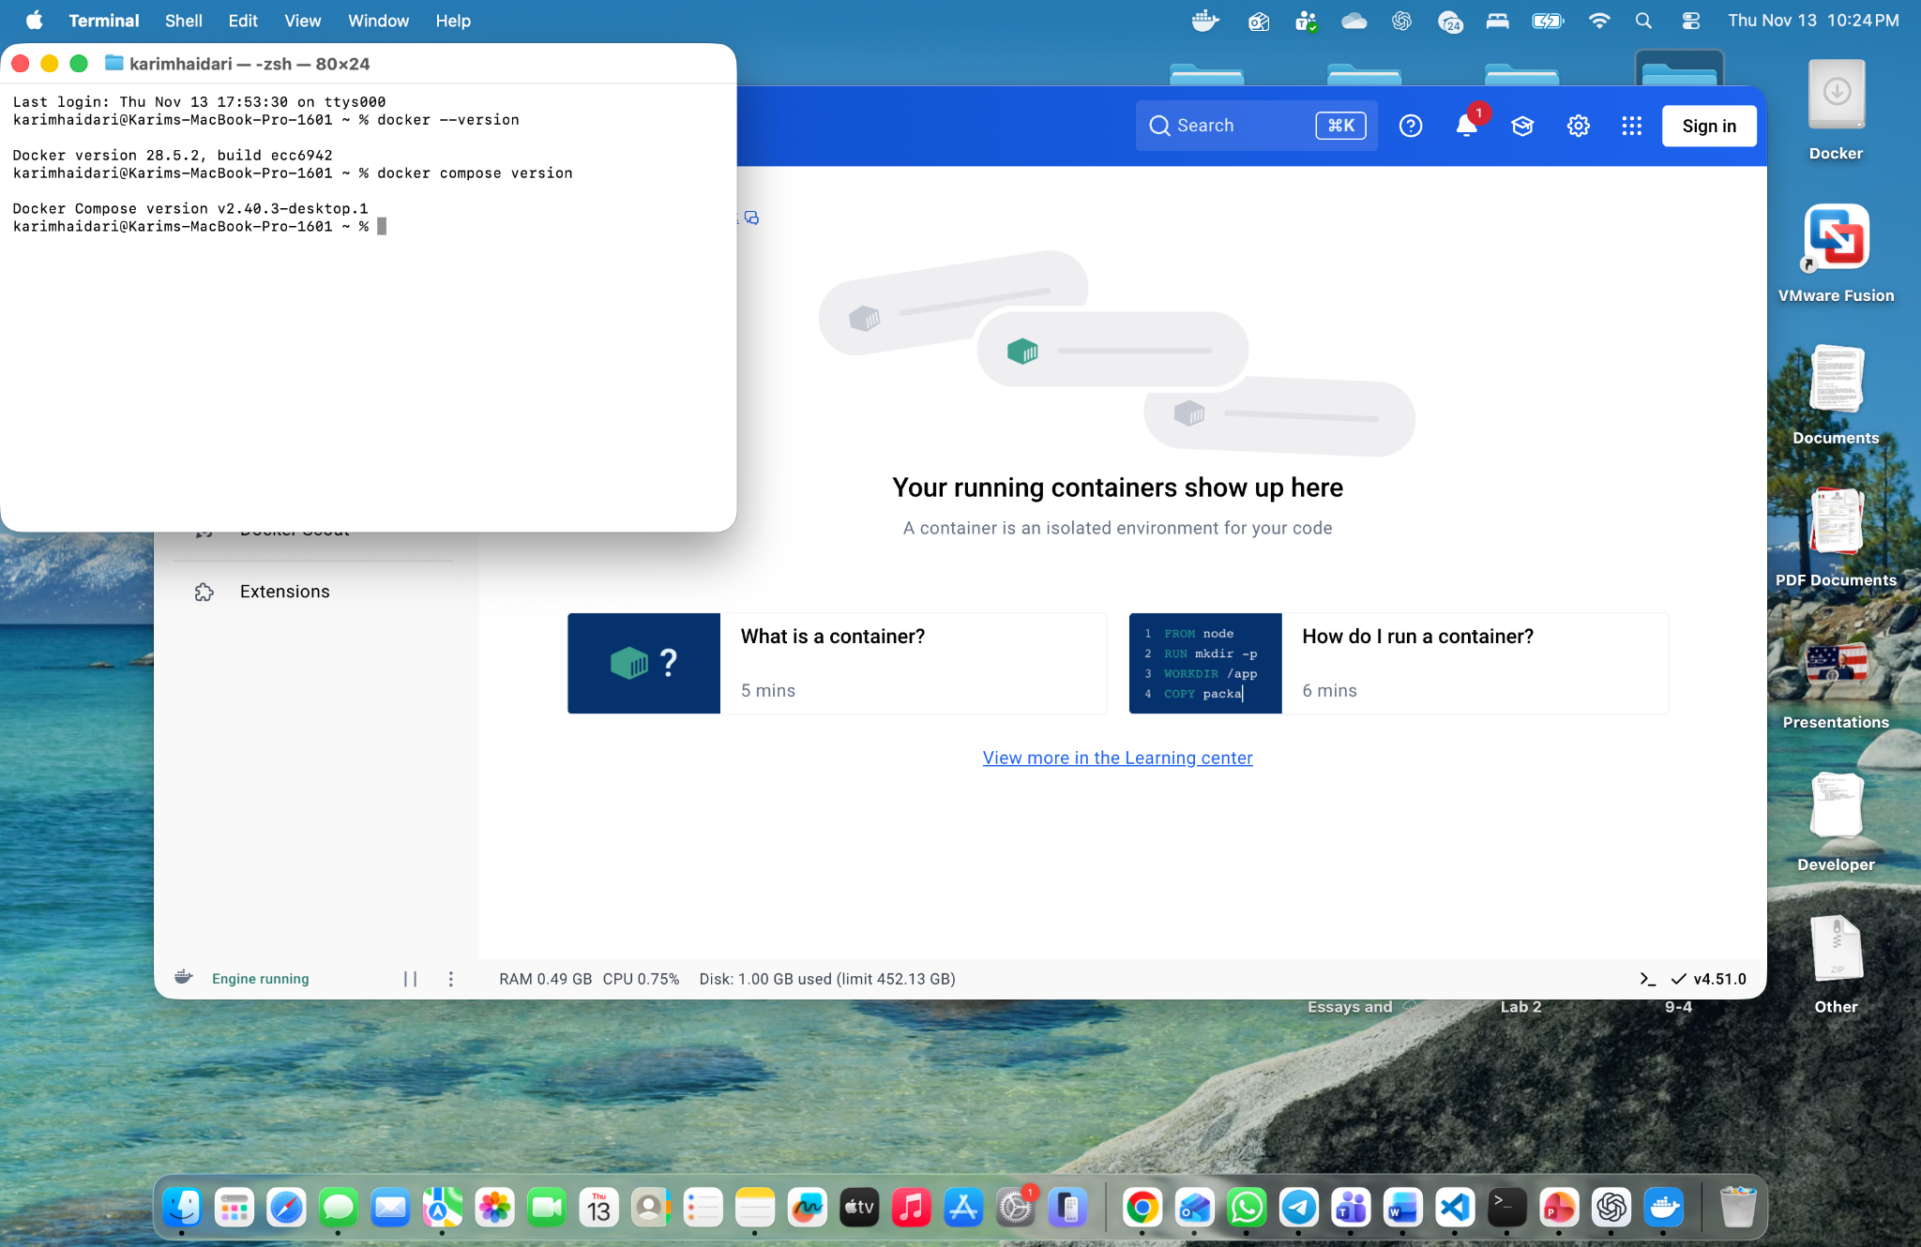

### Screenshot 2025-11-13 at 10.26.53 PM.png

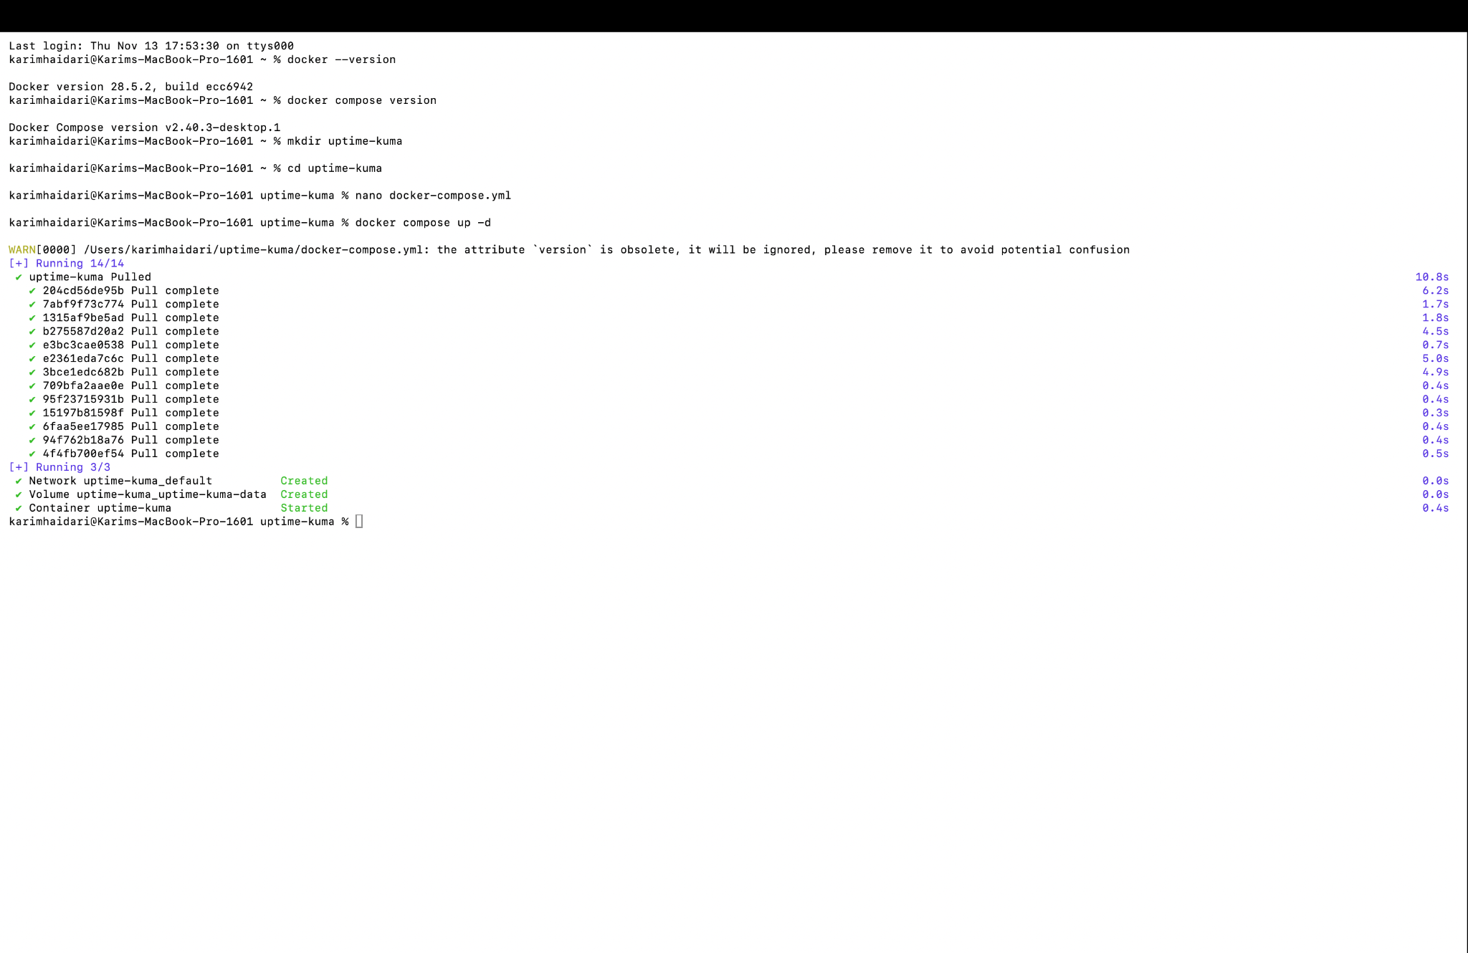

### Screenshot 2025-11-13 at 10.28.30 PM.png

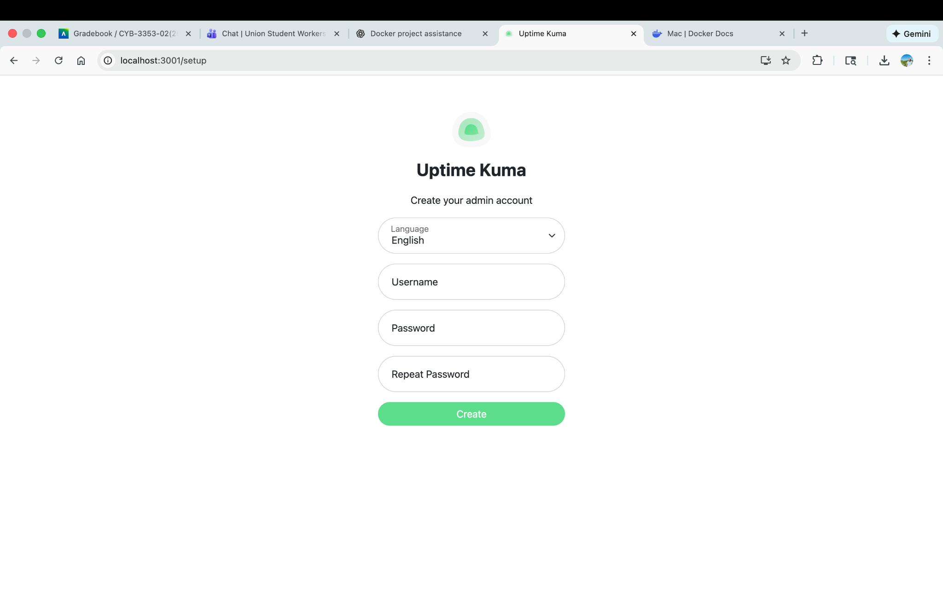

### Screenshot 2025-11-13 at 10.28.58 PM.png

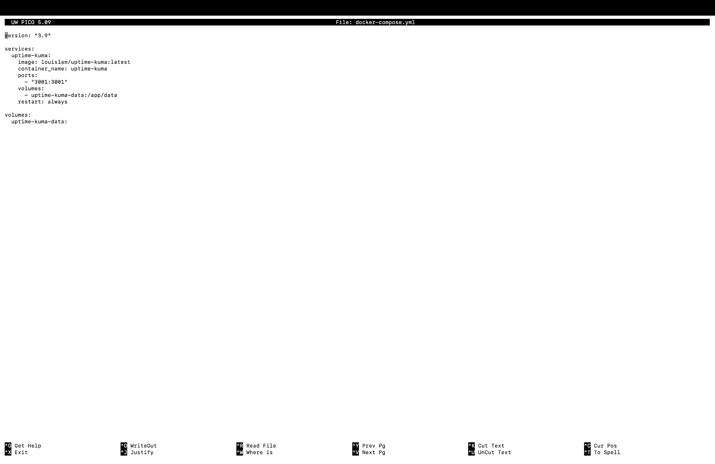

### Screenshot 2025-11-13 at 10.29.59 PM.png

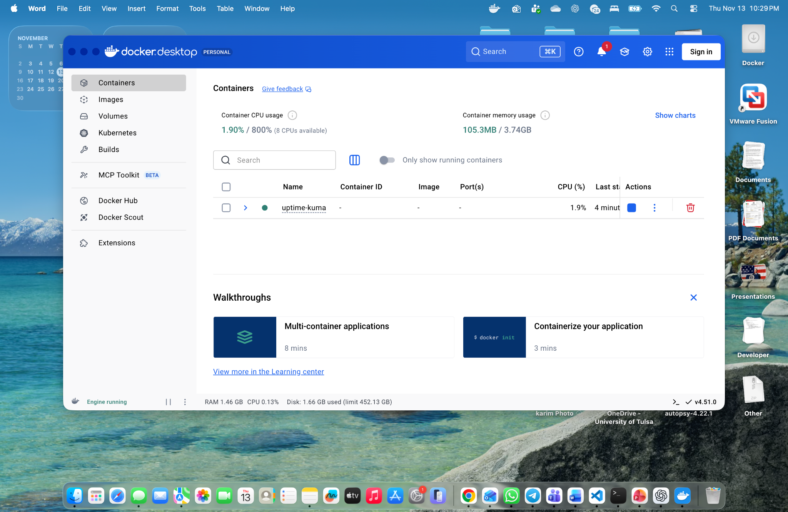

### Screenshot 2025-11-13 at 10.32.59 PM.png

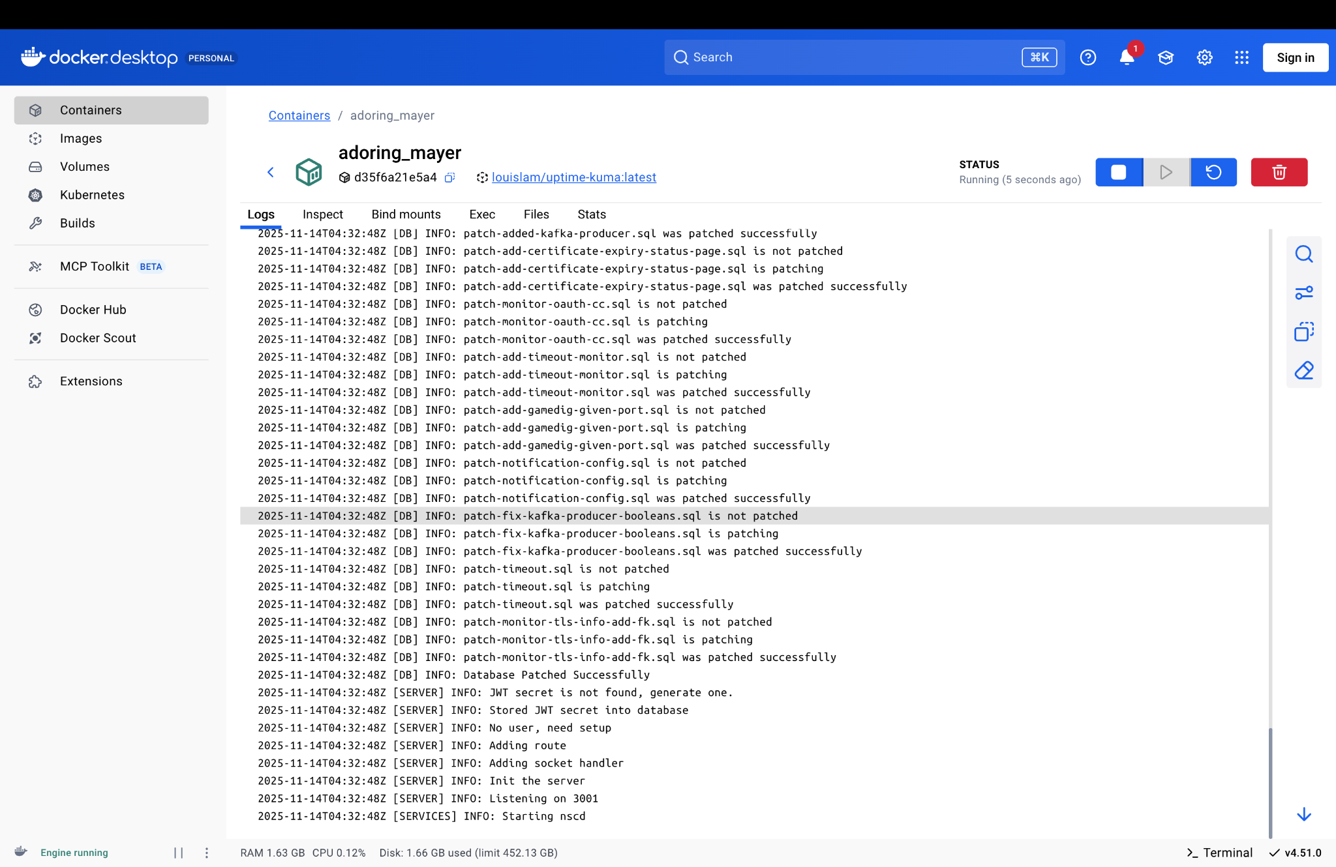

### Screenshot 2025-11-13 at 10.33.39 PM.png

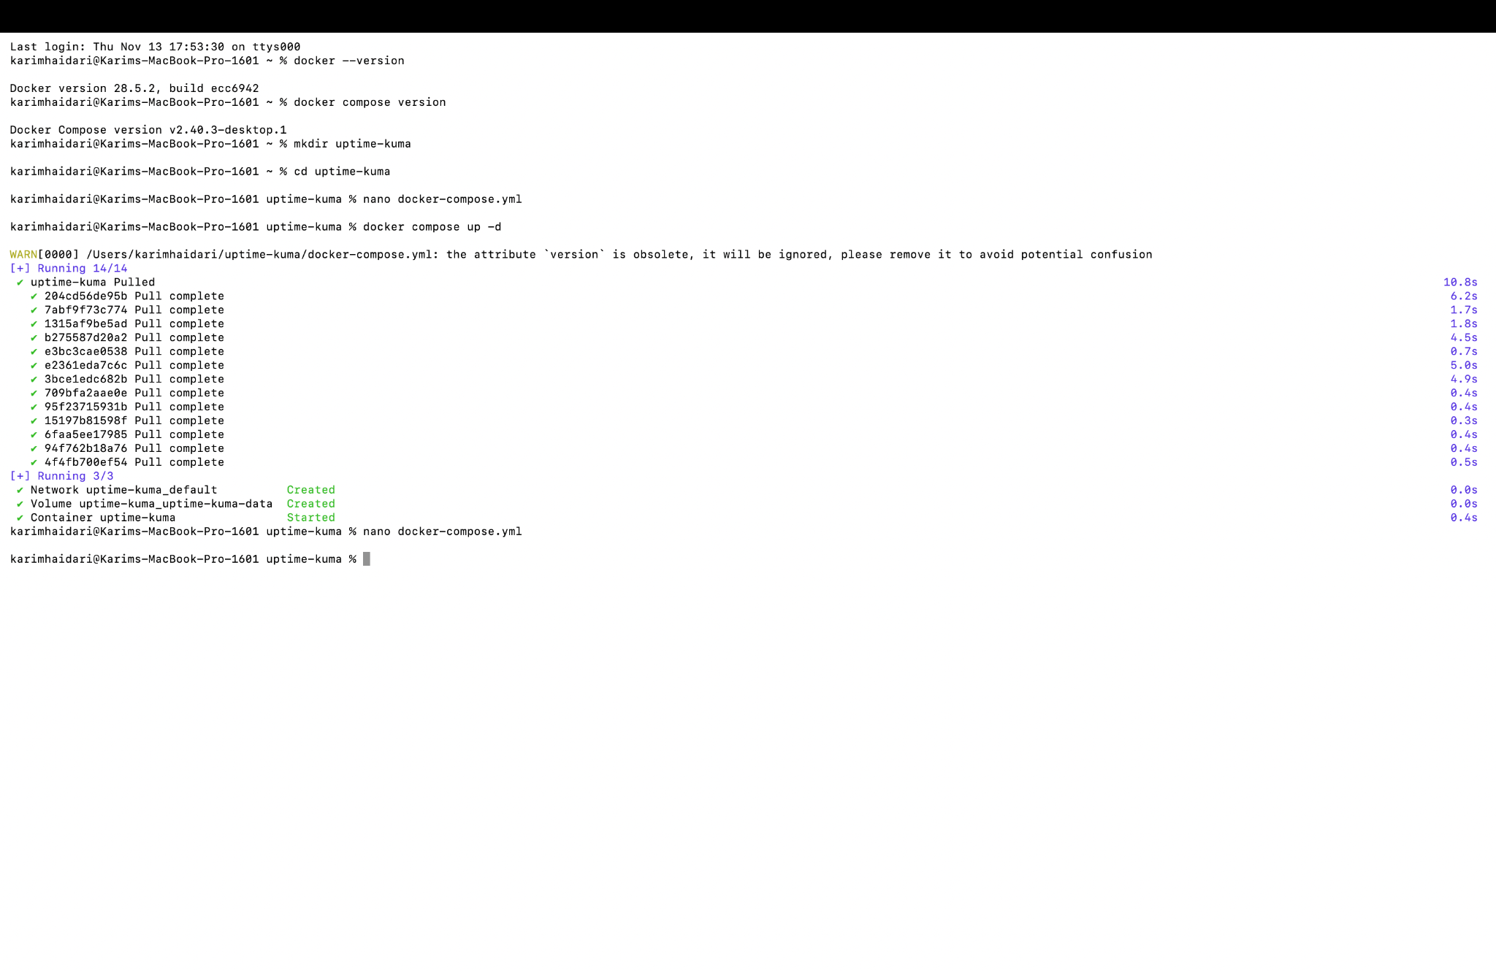

### Screenshot 2025-11-13 at 10.34.18 PM.png

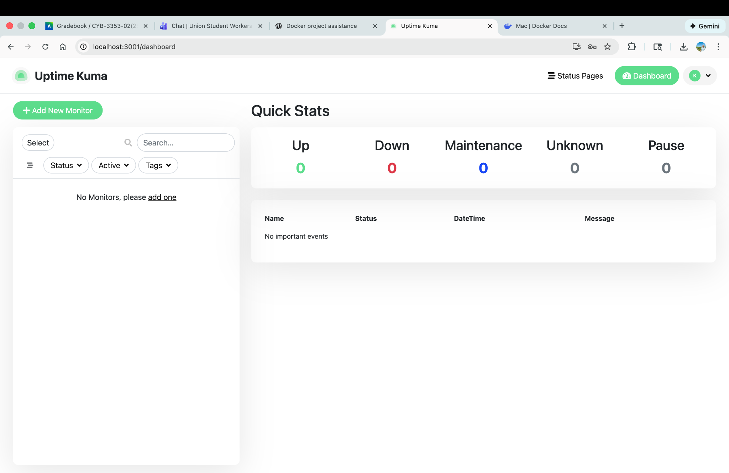

### Screenshot 2025-11-13 at 10.34.55 PM.png

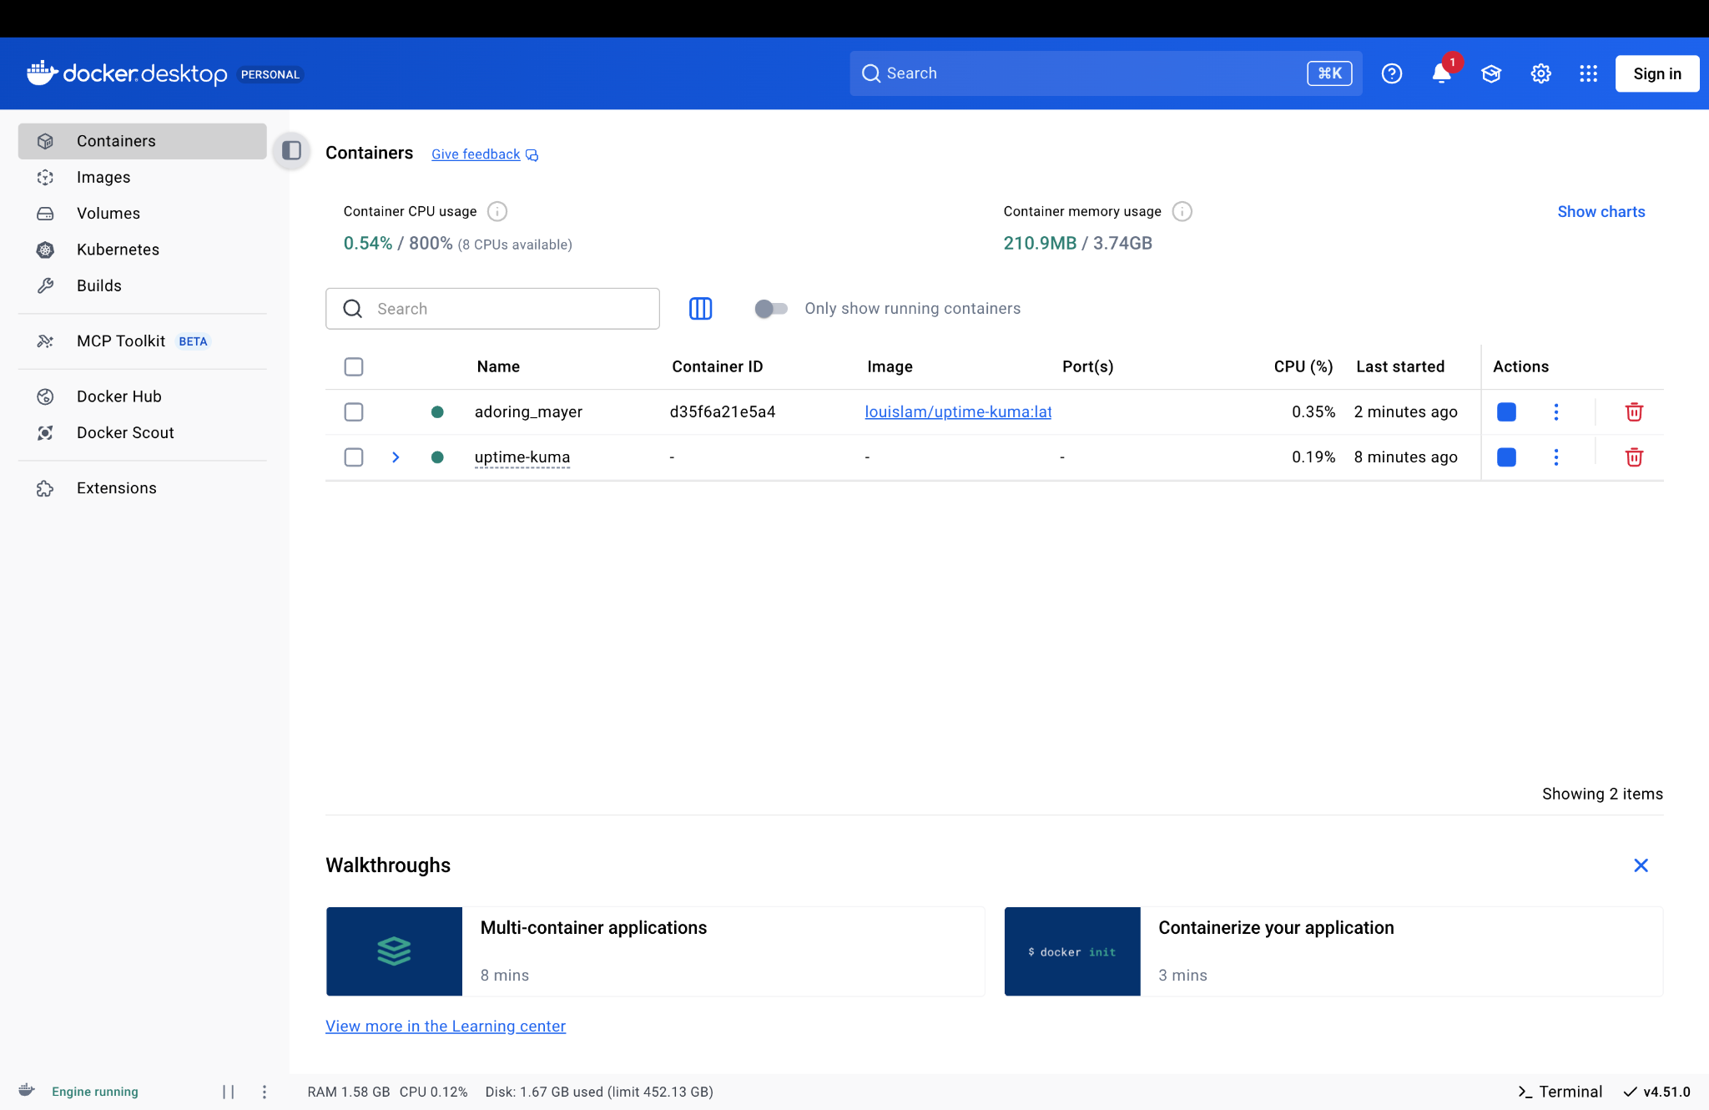

### Screenshot 2025-11-13 at 10.36.03 PM.png

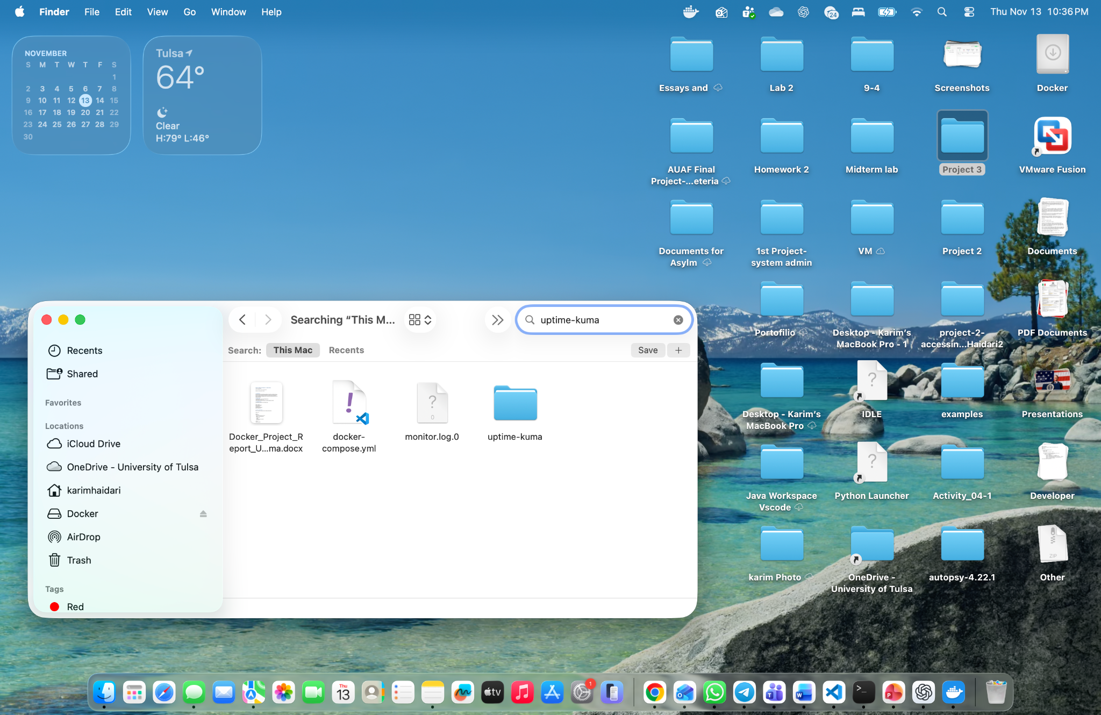

### Screenshot 2025-11-13 at 10.36.43 PM.png

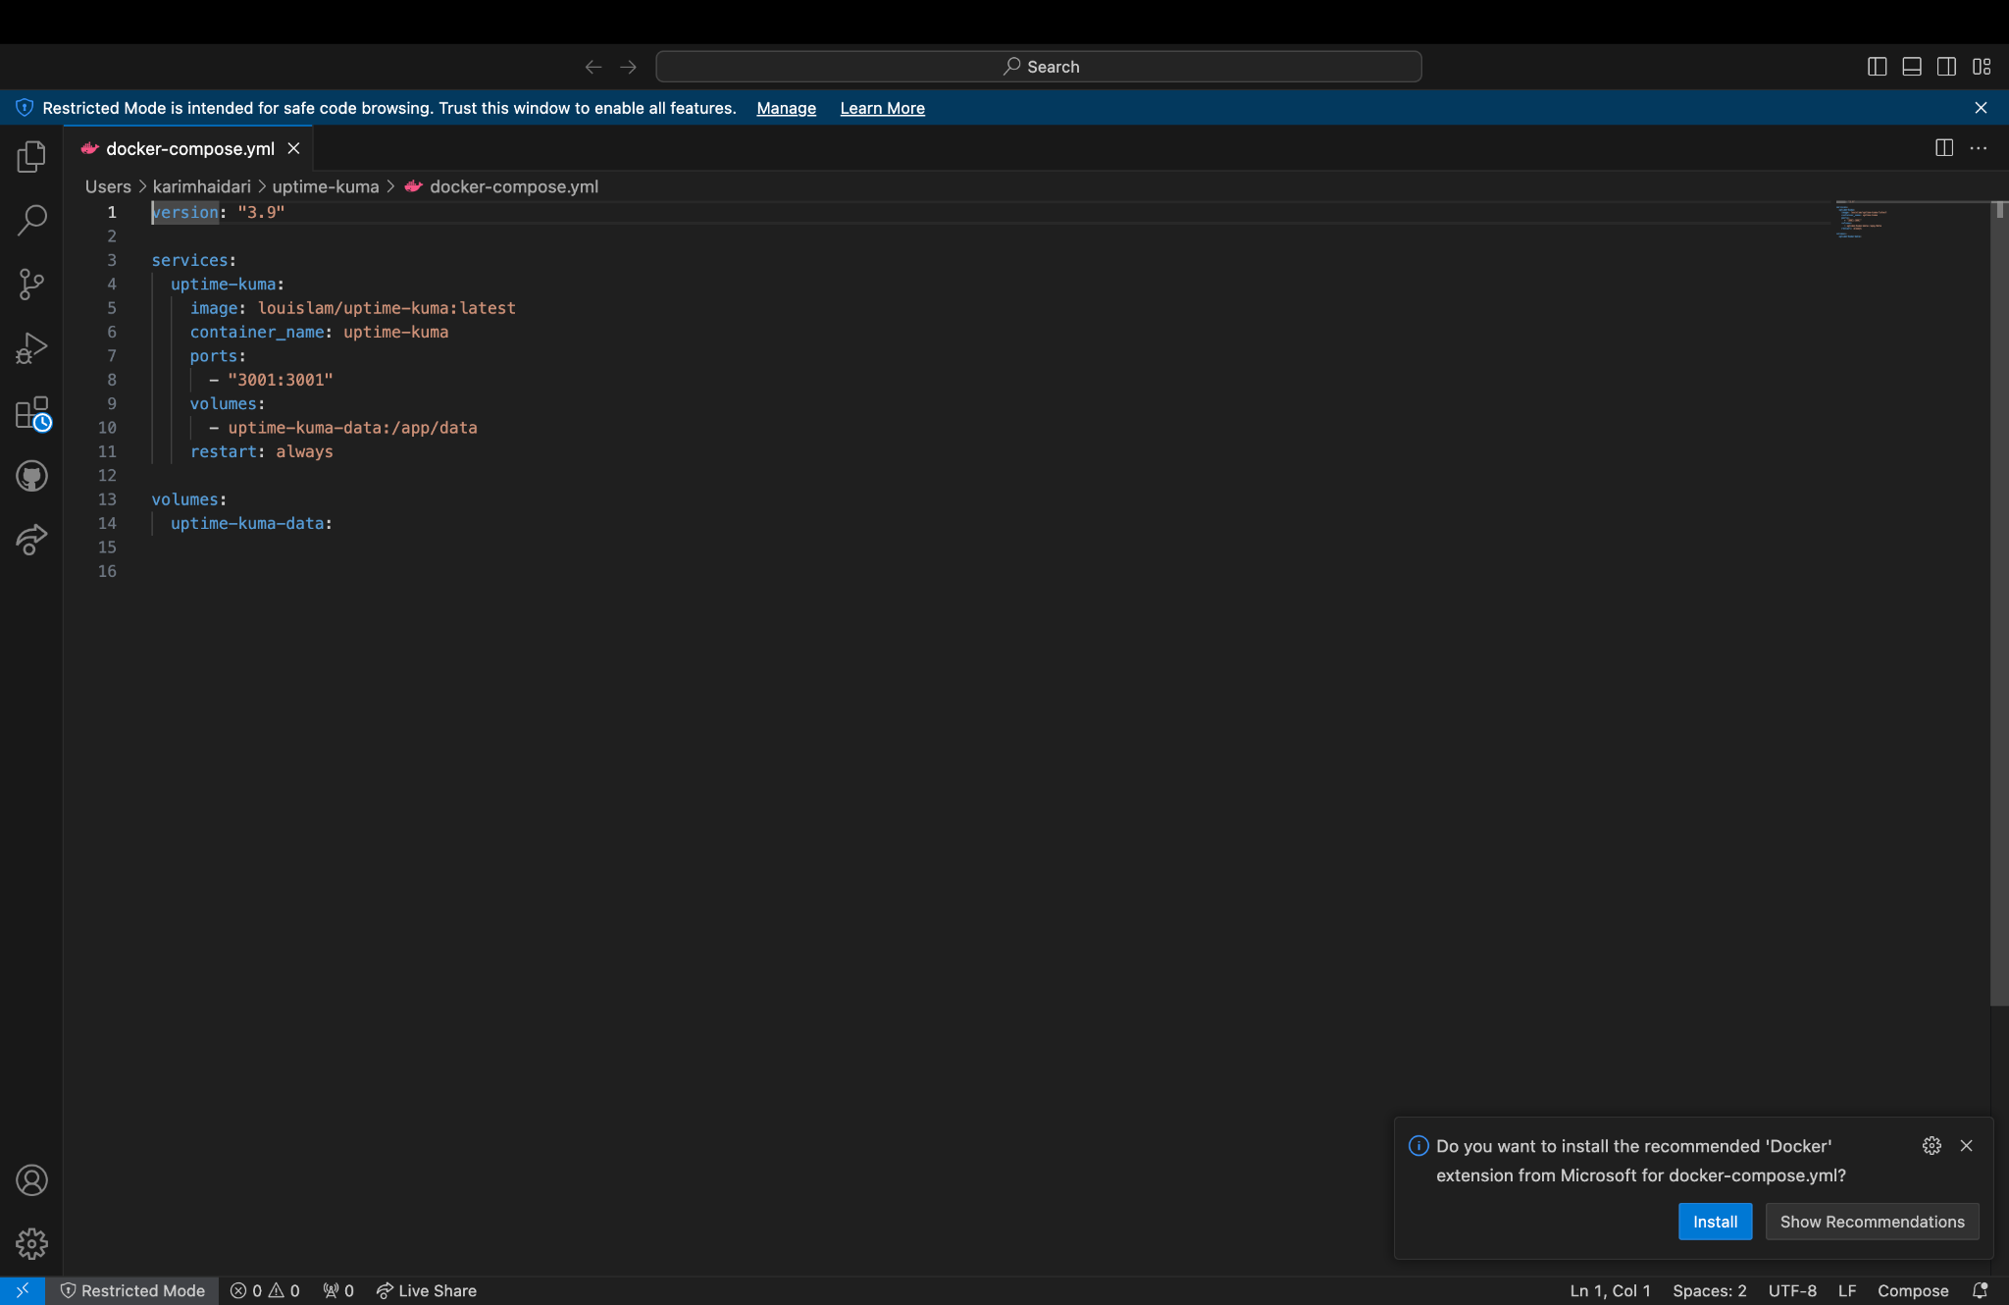

### Screenshot 2025-11-13 at 10.38.03 PM.png



### Screenshot 2025-11-13 at 10.39.26 PM.png

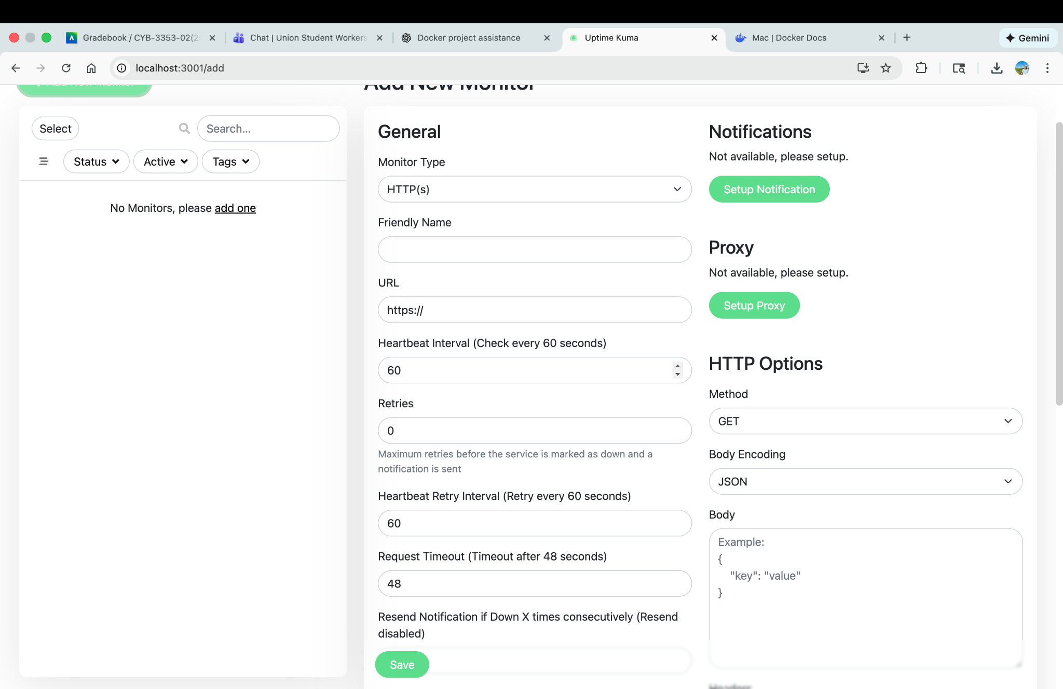

### Screenshot 2025-11-13 at 10.40.36 PM.png

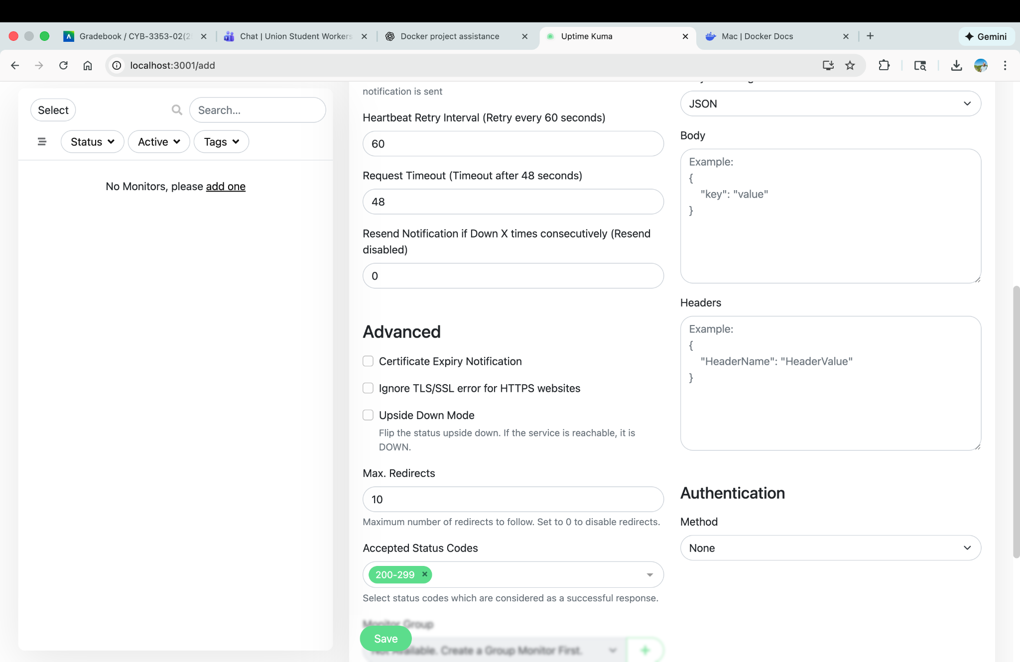

### Screenshot 2025-11-13 at 10.41.19 PM.png

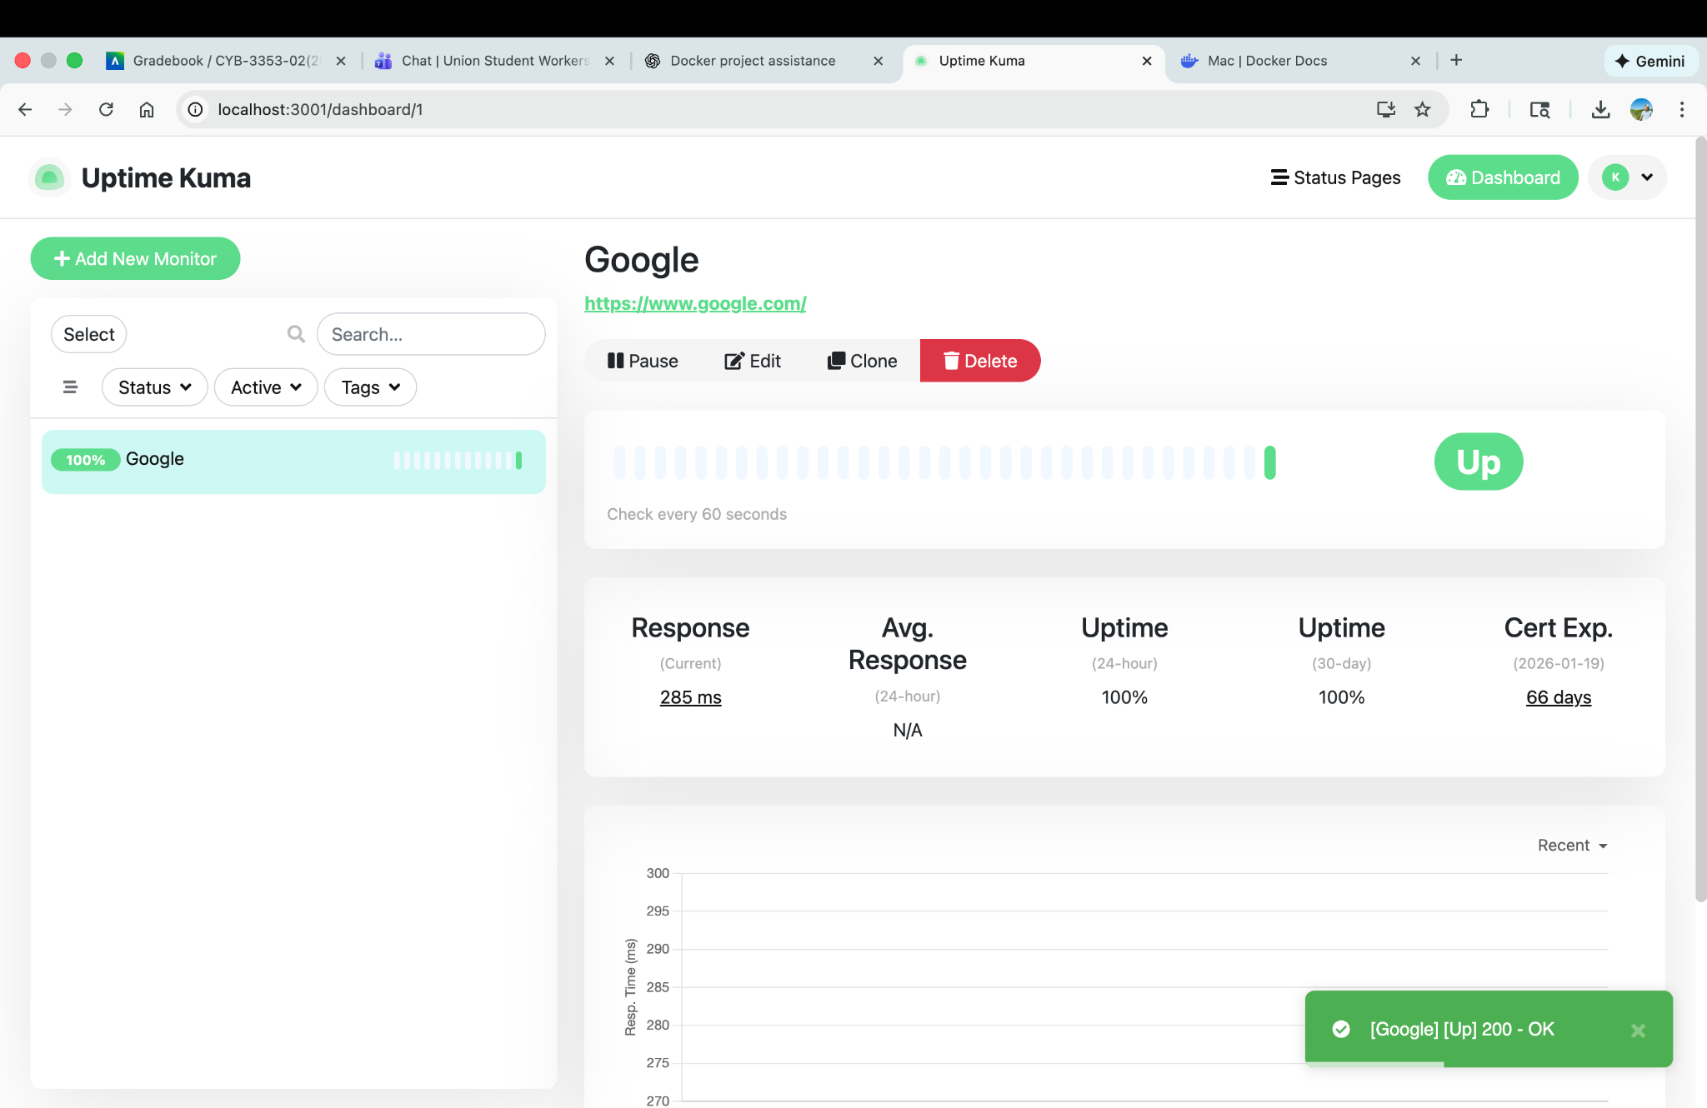

### Screenshot 2025-11-13 at 10.42.42 PM.png

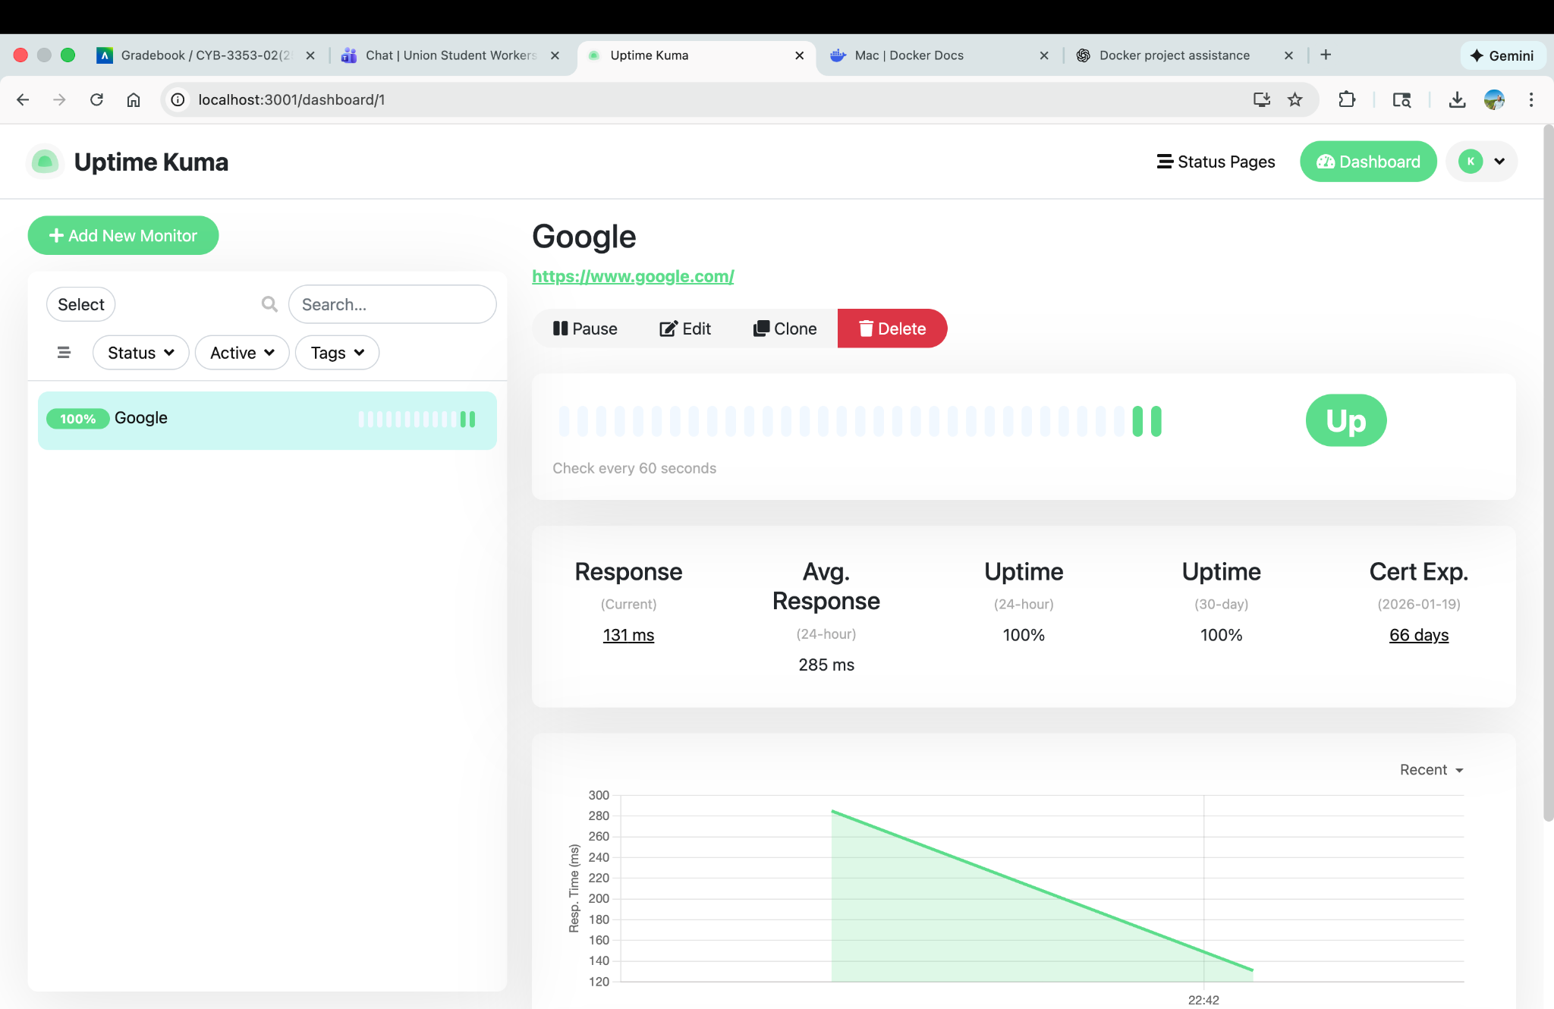

### Screenshot 2025-11-13 at 10.42.50 PM.png

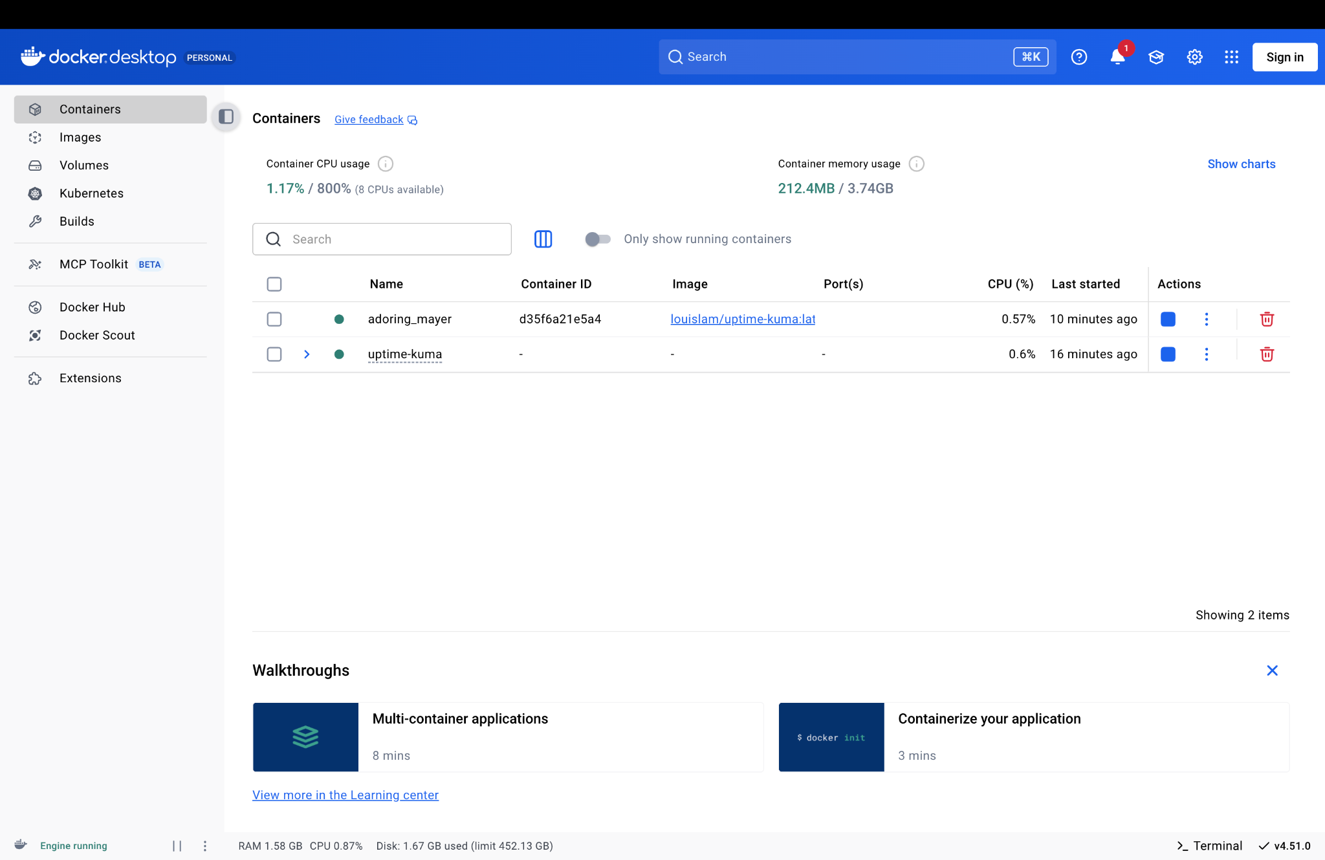

### Screenshot 2025-11-13 at 10.42.55 PM.png

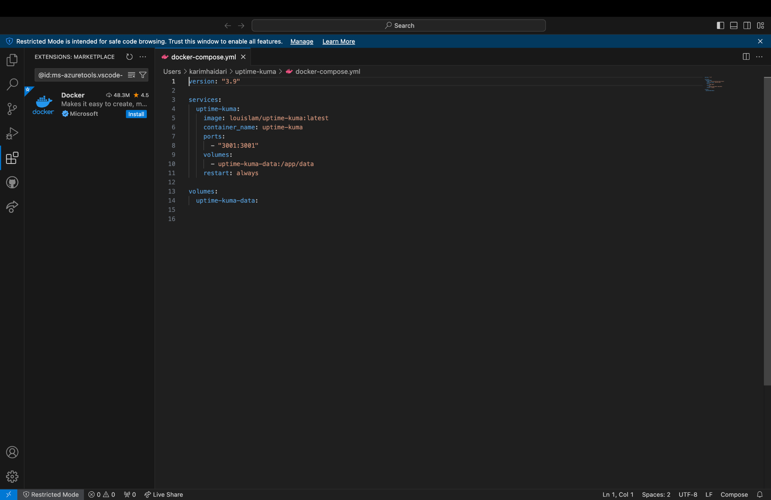

### Screenshot 2025-11-13 at 10.43.01 PM.png

